**Project 2 - Advance E-Commerce Website**

* ABSTRACT

Project is to develop a Advance E-commerce Website. The theme used in this project is of a marketing, consultancy and courses providing company e-commerce site ***(DevelopersGrace).*** The web page can be divided into 3- section namely,

1. The navigation bar
2. The middle section(Multiple pages)
3. Address section

The navigation bar includes options for user to navigate through the site and use the services available.

The middle section tells to the users about seller. It specifies the purpose of the site, services available to the user and many more

The address section provides address/contacts details of the outlets of the seller, social links, etc.

* OBJECTIVE

To develop an E-commerce site which offers marketing consultancy and web development tools to the users with the help of web development languages like HTML, CSS and Javascript, a working E-commerce page is to be developed.

It serves as a training website where learners can join and learn multiple courses like python programming, Machine learning and get job opportunities.

Primary objectives includes user friendly experience must be served to the user and the site must delivers attractive view to the user as well.

* INTRODUCTION

This project is about development of an E-commerce website given the name as **DevelopersGrace** which is a marketing site and provides web development services:

The development languages used in the projects are as follows:

**Web development** refers to the creating, building, and maintaining of websites. It includes aspects such as web design, web publishing, web programming, and database management. It is the creation of an application that works over the internet i.e. websites.

The word Web Development is made up of two words, that is:

Web: It refers to websites, web pages or anything that works over the internet.

Development: It refers to building the application from scratch.

HTML: HTML stands for Hyper Text Markup Language. It is used to design the front end portion of web pages using markup language. It acts as a skeleton for a website since it is used to make the structure of a website.

[CSS](https://www.geeksforgeeks.org/css-tutorials/): Cascading Style Sheets fondly referred to as CSS is a simply designed language intended to simplify the process of making web pages presentable. It is used to style our website.

[JavaScript](https://www.geeksforgeeks.org/javascript-tutorial/): JavaScript is a scripting language used to provide a dynamic behavior to our website.

* METHODOLOGY

The Project is developed by using general model which is normally used in development projects.

The sequential phases in model are −

**Requirement Gathering and analysis** − All possible requirements of the system to be developed are captured in this phase and documented in a requirement specification document.

**System Design** − The requirement specifications from first phase are studied in this phase and the system design is prepared. This system design helps in specifying hardware and system requirements and helps in defining the overall system architecture.

**Implementation** − With inputs from the system design, the system is first developed in small programs called units, which are integrated in the next phase. Each unit is developed and tested for its functionality, which is referred to as Unit Testing.

**Integration and Testing** − All the units developed in the implementation phase are integrated into a system after testing of each unit. Post integration the entire system is tested for any faults and failures

**Deployment of system** − Once the functional and non-functional testing is done; the product is deployed in the customer environment or released into the market.

**Maintenance** − There are some issues which come up in the client environment. To fix those issues, patches are released. Also to enhance the product some better versions are released. Maintenance is done to deliver these changes in the customer environment

* CODE

<!DOCTYPE html>

<html lang="en">

<head>

    <title>DevelopersGrace Marketing and Development Compant(Project 2: Advance E-commerce Company)</title>

    <link rel="stylesheet" href="style.css">

    <link rel="stylesheet"

     href="https://stackpath.bootstrapcdn.com/font-awesome/4.7.0/css/font-awesome.min.css"">

    <meta name=" viewport" content="width =device-width,initial-scale =1">

    <script src="https://cdn.jsdelivr.net/gh/cferdinandi/smooth-scroll/dist/smooth-scroll.polyfills.min.js"></script>

    <link rel="preconnect" href="https://fonts.googleapis.com">

    <link href="https://fonts.googleapis.com/css2?family=Kaushan+Script&family=Poppins:wght@100&display=swap" rel="stylesheet">

    <link rel="preconnect" href="https://fonts.gstatic.com" crossorigin>

    <link href="https://fonts.googleapis.com/css2?family=Libre+Bodoni&display=swap" rel="stylesheet">

</head>

<body>

    <section id="banner">

        <!-- <img src="web.jpg" class="logo"> -->

        <div class="banner-text">

            <h1>DevelopersGrace <br> Digital Marketing & Web <br>Development Company</h1>

            <p>A Digital Transformation Company. As a Digital <br>Marketing Company, we offers Digital Marketing, Web <br> Development & Digital Transformation Consulting. We search<br> experts who are result oriented in building online brand presence..</p>

            <div class="banner-btn">

                <a href="#"><span></span>Find Out</a>

                <a href="#"><span></span>Read More</a>

            </div>

        </div>

    </section>

    <div id="sideNav">

        <nav>

            <ul>

                <li><a href="#banner">HOME</a></li>

                <li><a href="#about">ABOUT US</a></li>

                <li><a href="#feature">FEATURES</a></li>

                <li><a href="#service">SERVICES</a></li>

                <li><a href="#training">TRAINING</a></li>

                <li><a href="#view">VIEW</a></li>

                <li><a href="#footer">CONTACT US</a></li>

            </ul>

        </nav>

    </div>

    <div id="menuBtn">

        <img src="menu.png" id="menu">

    </div>

    <!--About Us-->

    <section id="about">

        <div class="title-text">

            <p>ABOUT US</p>

            <h1>Our Vision</h1>

        </div>

        <div class="about-text">

            <p>Lorem ipsum dolor sit amet consectetur adipisicing elit. Aperiam a non error eos inventore ea laboriosam

                numquam dolorem molestiae vitae repellendus nihil, autem iste placeat impedit molestias! Id, facere

                ducimus. Lorem ipsum dolor sit, amet consectetur adipisicing elit. Quisquam, quia id perferendis

                inventore vitae, est repudiandae sint iure delectus reprehenderit ratione ipsam maiores rem optio, quas

                laborum magni maxime expedita. <br><br>Lorem ipsum dolor sit amet consectetur adipisicing elit. Mollitia

                eveniet nulla, iusto voluptate quae voluptatum recusandae reprehenderit, commodi asperiores animi,

                adipisci quis similique laboriosam vero? Est repudiandae temporibus quod <voluptates class="lorem">

                </voluptates><br><br>

                Lorem ipsum dolor sit amet consectetur adipisicing elit. Soluta, sequi eveniet. Aliquam pariatur ex nemo

                ipsum? Pariatur in explicabo doloribus suscipit assumenda iste amet eaque nihil, eius dolores accusamus

                molestiae. Lorem ipsum dolor sit amet consectetur adipisicing elit. Voluptatibus, totam ab similique

                eius molestiae nostrum earum temporibus, corporis necessitatibus eveniet tempore. Necessitatibus,

                commodi minus iusto quasi adipisci labore cumque optio. <br>

                Lorem, ipsum dolor sit amet consectetur adipisicing elit. Aut corporis enim rerum hic, reprehenderit

                harum vitae itaque necessitatibus minus placeat nostrum soluta delectus ad magni, nulla blanditiis, cum

                sunt perspiciatis.<br><br>

                Lorem ipsum dolor sit amet, consectetur adipisicing elit. Quas, quia fuga illum necessitatibus, impedit

                vel enim id animi cupiditate soluta autem! Accusamus delectus doloremque alias quis, dolore tempora

                molestias vitae. the<br>Lorem ipsum dolor sit amet consectetur adipisicing elit. Et possimus, hic,

                dolore cupiditate rerum, laborum illo sed maiores provident impedit esse. Itaque repellendus repudiandae

                qui debitis nulla ex repellat sit!</p>

        </div>

        <div class="about-box">

            <div class="about-img">

                <img src="web dev 22.jpg">

            </div>

            <div class="about-img">

                <img src="08.png">

            </div>

        </div>

    </section>

    <!--Features-->

    <section id="feature">

        <div class="title-text">

            <p>FEATURES</p>

            <h1>Why Choose Us</h1>

        </div>

        <div class="feature-box">

            <div class="features">

                <h1>Lorem ipsum dolor.</h1>

                <div class="features-desc">

                    <div class="feature-text">

                        <p>Lorem ipsum dolor sit amet consectetur adipisicing elit. Blanditiis praesentium quasi

                            inventore nesciunt repellendus repellat aliquid sit? Nam cumque, nesciunt obcaecati

                            praesentium itaque tempore magni voluptatum facere, eligendi nulla illo.<br>Lorem, ipsum

                            dolor sit amet consectetur adipisicing elit. Id rerum nihil recusandae corporis animi

                            aperiam reprehenderit aliquam. Voluptatum nisi blanditiis in asperiores tenetur quos alias

                            quam, ipsum perferendis illum provident!<br><br>

                            Lorem ipsum dolor sit amet consectetur adipisicing elit. Repellendus voluptatibus

                            exercitationem modi fugiat nulla perferendis, ea, aliquid delectus minus nemo veniam

                            doloribus blanditiis eligendi. Culpa numquam qui a sunt ratione.<br>Lorem ipsum dolor sit

                            amet consectetur adipisicing elit. Tenetur laboriosam temporibus voluptatem voluptatibus

                            possimus esse delectus, excepturi ipsa reprehenderit vel, voluptates, rerum assumenda alias

                            non? Adipisci, nihil ducimus! Cupiditate, saepe.<br>Lorem, ipsum dolor sit amet consectetur

                            adipisicing elit. Dolore harum voluptates fugiat placeat quis quaerat unde doloribus

                            similique pariatur quam laudantium veritatis ipsam et molestiae ratione ullam, quidem, iusto

                            minus.</p>

                    </div>

                </div>

                <h1>About us</h1>

                <div class="features-desc">

                    <div class="feature-text">

                        <p>Lorem ipsum dolor sit amet consectetur adipisicing elit. Recusandae quas pariatur tempora,

                            doloremque necessitatibus dolorem quaerat tempore non error excepturi. Officiis aperiam

                            aliquam voluptatum, impedit accusantium perspiciatis ullam reiciendis incidunt?<br>Lorem

                            ipsum dolor sit amet consectetur adipisicing elit. Eaque harum cumque a, vitae dolore ut

                            illo tempora, quia, quis tempore error modi temporibus doloremque maxime enim dicta!

                            Praesentium, quia eveniet?<br>Lorem ipsum dolor sit amet, consectetur adipisicing elit. Eius

                            eveniet dignissimos quae, laudantium assumenda sint obcaecati modi nostrum, saepe beatae

                            delectus ipsum asperiores tempora vel sit eligendi, neque enim fuga!<br>Lorem ipsum dolor

                            sit amet, consectetur adipisicing elit. Amet aspernatur rem natus. Est aliquid natus facere

                            blanditiis quisquam. Vitae cum dignissimos aperiam vel maxime ratione aspernatur ipsa sint

                            eveniet reprehenderit.<br>Lorem ipsum dolor sit amet consectetur adipisicing elit. Ducimus

                            laborum rerum voluptas odio fugiat totam deleniti perferendis eos maiores minima deserunt

                            vero voluptatem vel commodi, reprehenderit nesciunt voluptate sit fuga?<br>Lorem ipsum dolor

                            sit amet consectetur adipisicing elit. Illo similique perspiciatis explicabo impedit debitis

                            fuga eum laudantium quasi, facere natus corporis quia consequatur est deleniti. Veniam

                            excepturi ut eligendi eum!<br></p>

                    </div>

                </div>

            </div>

            <div class="features-img">

                <img src="e.jpg">

            </div>

        </div>

    </section>

    <!--Services-->

    <section id="service">

        <div class="title-text">

            <p>SERVICES</p>

            <h1>We Provide Better</h1>

        </div>

        <div class="service-box">

            <div class="single-service">

                <img src="6.png">

                <div class="overlay"></div>

                <div class="service-desc">

                    <h3>Social Media Marketing Services</h3>

                    <hr>

                    <p>Lorem ipsum dolor sit, amet consectetur adipisicing elit. Aliquid ullam consectetur, optio ipsa

                        harum sunt perspiciatis fugit illum ex quaerat voluptatibus doloribus ratione nobis nostrum hic!

                        Dicta cupiditate laboriosam minima.</p>

                </div>

            </div>

            <div class="single-service">

                <img src="9.jpg">

                <div class="overlay"></div>

                <div class="service-desc">

                    <h3>SEO Service Company</h3>

                    <hr>

                    <p>DevelopersGraceis the leading SEO service company in India as well as provides service across the

                        globe.</p>

                </div>

            </div>

            <div class="single-service">

                <img src="10.jpg">

                <div class="overlay"></div>

                <div class="service-desc">

                    <h3>Pay Per Click Management</h3>

                    <hr>

                    <p>DevelopersGrace is a PPC services company that helps you grow faster and generate more ROAS (Return On

                        Ad Spend).</p>

                </div>

            </div>

            <div class="single-service">

                <img src="11.jpg">

                <div class="overlay"></div>

                <div class="service-desc">

                    <h3>Web Development Services</h3>

                    <hr>

                    <p>Lorem ipsum dolor sit amet consectetur adipisicing elit. Ad sit cumque placeat esse, tempora reiciendis odit? Modi tempore veritatis labore rerum illum! Explicabo sed?</p>

                </div>

            </div>

        </div>

    </section>

    <!--Training-->

    <section id="training">

        <div class="title-text">

            <p>TRAINING</p>

            <h1>Other Domains we provide training in..</h1>

        </div>

        <div class="training-box">

            <div class="single-training">

                <img src="l.jpg">

            </div>

            <div class="single-training">

                <img src="k.jpg">

            </div>

            <div class="single-training">

                <img src="j.jpg">

            </div>

            <div class="single-training">

                <img src="g.jpg">

            </div>

    </section>

    </section> -->

    <!--view-->

    <section id="view">

        <div class="title-text">

            <p>VIEW</p>

            <h1>DeveloperGrace</h1>

        </div>

        <div class="view-box">

            <div class="single-training">

                <img src="lll.jpg">

            </div>

        </div>

    </section>

    <!--footer-->

    <section id="footer">

        <div class="title-text">

            <p>CONTACT US</p>

            <h1>Support Team</h1><br>

            <h2>DevelopersGrace</h2>

        </div>

        <div class="footer-row">

            <div class="footer-left">

                <h1>Contact Our World Class Support Team<br><br></h1>

                <p>Having queries or any questions, We are DevelopersGrace<br>Transformation Company. Feel free to

                    ask and let your all<br>queries be cleared with our support team.<br>

                    Give us a call and get all your confusion to be cleared.<br>

                    So what are you thinking about now?</p>

            </div>

            <div class="footer-right">

                <h1>Get In Touch with us!<br><br></h1>

                <p><i class="fa fa-map-marker"></i>Address:C/O: Namdeo Nagar Colony, Near Railway

                    Crossing<br>Shanti Nagar, Nagpur (440017)</p>

                <p><i class="fa fa-paper-plane"></i>Email:rajatbijekar360@gmail</p>

                <p><i class="fa fa-phone"></i>Phone:9890544466</p>

            </div>

        </div>

        <div class="social-links">

            <i class="fa fa-facebook"></i>

            <i class="fa fa-instagram"></i>

            <i class="fa fa-twitter"></i>

            <i class="fa fa-linkedin"></i>

            <i class="fa fa-youtube"></i>

        </div>

    </section>

    <script>

        var menuBtn = document.getElementById("menuBtn")

        var sideNav = document.getElementById("sideNav")

        var menu = document.getElementById("menu")

        sideNav.style.right = "-200px";

        menuBtn.onclick = function () {

            if (sideNav.style.right == "-200px") {

                sideNav.style.right = "0";

                menu.src = "close.png";

            }

            else {

                sideNav.style.right = "-200px";

                menu.src = "menu.png";

            }

        }

        var scroll = new SmoothScroll('a[href*="#"]', {

            speed: 1000,

            speedAsDuration: true

        });

    </script>

</body>

</html>

<!DOCTYPE html>

<html lang="en">

<head>

    <title>DevelopersGrace Marketing and Development Compant(Project 2: Advance E-commerce Company)</title>

    <link rel="stylesheet" href="style.css">

    <link rel="stylesheet"

     href="https://stackpath.bootstrapcdn.com/font-awesome/4.7.0/css/font-awesome.min.css"">

    <meta name=" viewport" content="width =device-width,initial-scale =1">

    <script src="https://cdn.jsdelivr.net/gh/cferdinandi/smooth-scroll/dist/smooth-scroll.polyfills.min.js"></script>

    <link rel="preconnect" href="https://fonts.googleapis.com">

    <link href="https://fonts.googleapis.com/css2?family=Kaushan+Script&family=Poppins:wght@100&display=swap" rel="stylesheet">

    <link rel="preconnect" href="https://fonts.gstatic.com" crossorigin>

    <link href="https://fonts.googleapis.com/css2?family=Libre+Bodoni&display=swap" rel="stylesheet">

</head>

<body>

    <section id="banner">

*<!-- <img src="web.jpg" class="logo"> -->*

        <div class="banner-text">

            <h1>DevelopersGrace <br> Digital Marketing & Web <br>Development Company</h1>

            <p>A Digital Transformation Company. As a Digital <br>Marketing Company, we offers Digital Marketing, Web <br> Development & Digital Transformation Consulting. We search<br> experts who are result oriented in building online brand presence..</p>

            <div class="banner-btn">

                <a href="#"><span></span>Find Out</a>

                <a href="#"><span></span>Read More</a>

            </div>

        </div>

    </section>

    <div id="sideNav">

        <nav>

            <ul>

                <li><a href="#banner">HOME</a></li>

                <li><a href="#about">ABOUT US</a></li>

                <li><a href="#feature">FEATURES</a></li>

                <li><a href="#service">SERVICES</a></li>

                <li><a href="#training">TRAINING</a></li>

                <li><a href="#view">VIEW</a></li>

                <li><a href="#footer">CONTACT US</a></li>

            </ul>

        </nav>

    </div>

    <div id="menuBtn">

        <img src="menu.png" id="menu">

    </div>

*<!--About Us-->*

    <section id="about">

        <div class="title-text">

            <p>ABOUT US</p>

            <h1>Our Vision</h1>

        </div>

        <div class="about-text">

            <p>Lorem ipsum dolor sit amet consectetur adipisicing elit. Aperiam a non error eos inventore ea laboriosam

                numquam dolorem molestiae vitae repellendus nihil, autem iste placeat impedit molestias! Id, facere

                ducimus. Lorem ipsum dolor sit, amet consectetur adipisicing elit. Quisquam, quia id perferendis

                inventore vitae, est repudiandae sint iure delectus reprehenderit ratione ipsam maiores rem optio, quas

                laborum magni maxime expedita. <br><br>Lorem ipsum dolor sit amet consectetur adipisicing elit. Mollitia

                eveniet nulla, iusto voluptate quae voluptatum recusandae reprehenderit, commodi asperiores animi,

                adipisci quis similique laboriosam vero? Est repudiandae temporibus quod <voluptates class="lorem">

                </voluptates><br><br>

                Lorem ipsum dolor sit amet consectetur adipisicing elit. Soluta, sequi eveniet. Aliquam pariatur ex nemo

                ipsum? Pariatur in explicabo doloribus suscipit assumenda iste amet eaque nihil, eius dolores accusamus

                molestiae. Lorem ipsum dolor sit amet consectetur adipisicing elit. Voluptatibus, totam ab similique

                eius molestiae nostrum earum temporibus, corporis necessitatibus eveniet tempore. Necessitatibus,

                commodi minus iusto quasi adipisci labore cumque optio. <br>

                Lorem, ipsum dolor sit amet consectetur adipisicing elit. Aut corporis enim rerum hic, reprehenderit

                harum vitae itaque necessitatibus minus placeat nostrum soluta delectus ad magni, nulla blanditiis, cum

                sunt perspiciatis.<br><br>

                Lorem ipsum dolor sit amet, consectetur adipisicing elit. Quas, quia fuga illum necessitatibus, impedit

                vel enim id animi cupiditate soluta autem! Accusamus delectus doloremque alias quis, dolore tempora

                molestias vitae. the<br>Lorem ipsum dolor sit amet consectetur adipisicing elit. Et possimus, hic,

                dolore cupiditate rerum, laborum illo sed maiores provident impedit esse. Itaque repellendus repudiandae

                qui debitis nulla ex repellat sit!</p>

        </div>

        <div class="about-box">

            <div class="about-img">

                <img src="web dev 22.jpg">

            </div>

            <div class="about-img">

                <img src="08.png">

            </div>

        </div>

    </section>

*<!--Features-->*

    <section id="feature">

        <div class="title-text">

            <p>FEATURES</p>

            <h1>Why Choose Us</h1>

        </div>

        <div class="feature-box">

            <div class="features">

                <h1>Lorem ipsum dolor.</h1>

                <div class="features-desc">

                    <div class="feature-text">

                        <p>Lorem ipsum dolor sit amet consectetur adipisicing elit. Blanditiis praesentium quasi

                            inventore nesciunt repellendus repellat aliquid sit? Nam cumque, nesciunt obcaecati

                            praesentium itaque tempore magni voluptatum facere, eligendi nulla illo.<br>Lorem, ipsum

                            dolor sit amet consectetur adipisicing elit. Id rerum nihil recusandae corporis animi

                            aperiam reprehenderit aliquam. Voluptatum nisi blanditiis in asperiores tenetur quos alias

                            quam, ipsum perferendis illum provident!<br><br>

                            Lorem ipsum dolor sit amet consectetur adipisicing elit. Repellendus voluptatibus

                            exercitationem modi fugiat nulla perferendis, ea, aliquid delectus minus nemo veniam

                            doloribus blanditiis eligendi. Culpa numquam qui a sunt ratione.<br>Lorem ipsum dolor sit

                            amet consectetur adipisicing elit. Tenetur laboriosam temporibus voluptatem voluptatibus

                            possimus esse delectus, excepturi ipsa reprehenderit vel, voluptates, rerum assumenda alias

                            non? Adipisci, nihil ducimus! Cupiditate, saepe.<br>Lorem, ipsum dolor sit amet consectetur

                            adipisicing elit. Dolore harum voluptates fugiat placeat quis quaerat unde doloribus

                            similique pariatur quam laudantium veritatis ipsam et molestiae ratione ullam, quidem, iusto

                            minus.</p>

                    </div>

                </div>

                <h1>About us</h1>

                <div class="features-desc">

                    <div class="feature-text">

                        <p>Lorem ipsum dolor sit amet consectetur adipisicing elit. Recusandae quas pariatur tempora,

                            doloremque necessitatibus dolorem quaerat tempore non error excepturi. Officiis aperiam

                            aliquam voluptatum, impedit accusantium perspiciatis ullam reiciendis incidunt?<br>Lorem

                            ipsum dolor sit amet consectetur adipisicing elit. Eaque harum cumque a, vitae dolore ut

                            illo tempora, quia, quis tempore error modi temporibus doloremque maxime enim dicta!

                            Praesentium, quia eveniet?<br>Lorem ipsum dolor sit amet, consectetur adipisicing elit. Eius

                            eveniet dignissimos quae, laudantium assumenda sint obcaecati modi nostrum, saepe beatae

                            delectus ipsum asperiores tempora vel sit eligendi, neque enim fuga!<br>Lorem ipsum dolor

                            sit amet, consectetur adipisicing elit. Amet aspernatur rem natus. Est aliquid natus facere

                            blanditiis quisquam. Vitae cum dignissimos aperiam vel maxime ratione aspernatur ipsa sint

                            eveniet reprehenderit.<br>Lorem ipsum dolor sit amet consectetur adipisicing elit. Ducimus

                            laborum rerum voluptas odio fugiat totam deleniti perferendis eos maiores minima deserunt

                            vero voluptatem vel commodi, reprehenderit nesciunt voluptate sit fuga?<br>Lorem ipsum dolor

                            sit amet consectetur adipisicing elit. Illo similique perspiciatis explicabo impedit debitis

                            fuga eum laudantium quasi, facere natus corporis quia consequatur est deleniti. Veniam

                            excepturi ut eligendi eum!<br></p>

                    </div>

                </div>

            </div>

            <div class="features-img">

                <img src="e.jpg">

            </div>

        </div>

    </section>

*<!--Services-->*

    <section id="service">

        <div class="title-text">

            <p>SERVICES</p>

            <h1>We Provide Better</h1>

        </div>

        <div class="service-box">

            <div class="single-service">

                <img src="6.png">

                <div class="overlay"></div>

                <div class="service-desc">

                    <h3>Social Media Marketing Services</h3>

                    <hr>

                    <p>Lorem ipsum dolor sit, amet consectetur adipisicing elit. Aliquid ullam consectetur, optio ipsa

                        harum sunt perspiciatis fugit illum ex quaerat voluptatibus doloribus ratione nobis nostrum hic!

                        Dicta cupiditate laboriosam minima.</p>

                </div>

            </div>

            <div class="single-service">

                <img src="9.jpg">

                <div class="overlay"></div>

                <div class="service-desc">

                    <h3>SEO Service Company</h3>

                    <hr>

                    <p>DevelopersGraceis the leading SEO service company in India as well as provides service across the

                        globe.</p>

                </div>

            </div>

            <div class="single-service">

                <img src="10.jpg">

                <div class="overlay"></div>

                <div class="service-desc">

                    <h3>Pay Per Click Management</h3>

                    <hr>

                    <p>DevelopersGrace is a PPC services company that helps you grow faster and generate more ROAS (Return On

                        Ad Spend).</p>

                </div>

            </div>

            <div class="single-service">

                <img src="11.jpg">

                <div class="overlay"></div>

                <div class="service-desc">

                    <h3>Web Development Services</h3>

                    <hr>

                    <p>Lorem ipsum dolor sit amet consectetur adipisicing elit. Ad sit cumque placeat esse, tempora reiciendis odit? Modi tempore veritatis labore rerum illum! Explicabo sed?</p>

                </div>

            </div>

        </div>

    </section>

*<!--Training-->*

    <section id="training">

        <div class="title-text">

            <p>TRAINING</p>

            <h1>Other Domains we provide training in..</h1>

        </div>

        <div class="training-box">

            <div class="single-training">

                <img src="l.jpg">

            </div>

            <div class="single-training">

                <img src="k.jpg">

            </div>

            <div class="single-training">

                <img src="j.jpg">

            </div>

            <div class="single-training">

                <img src="g.jpg">

            </div>

    </section>

    </section> -->

*<!--view-->*

    <section id="view">

        <div class="title-text">

            <p>VIEW</p>

            <h1>DeveloperGrace</h1>

        </div>

        <div class="view-box">

            <div class="single-training">

                <img src="lll.jpg">

            </div>

        </div>

    </section>

*<!--footer-->*

    <section id="footer">

        <div class="title-text">

            <p>CONTACT US</p>

            <h1>Support Team</h1><br>

            <h2>DevelopersGrace</h2>

        </div>

        <div class="footer-row">

            <div class="footer-left">

                <h1>Contact Our World Class Support Team<br><br></h1>

                <p>Having queries or any questions, We are DevelopersGrace<br>Transformation Company. Feel free to

                    ask and let your all<br>queries be cleared with our support team.<br>

                    Give us a call and get all your confusion to be cleared.<br>

                    So what are you thinking about now?</p>

            </div>

            <div class="footer-right">

                <h1>Get In Touch with us!<br><br></h1>

                <p><i class="fa fa-map-marker"></i>Address:C/O: Namdeo Nagar Colony, Near Railway

                    Crossing<br>Shanti Nagar, Nagpur (440017)</p>

                <p><i class="fa fa-paper-plane"></i>Email:rajatbijekar360@gmail</p>

                <p><i class="fa fa-phone"></i>Phone:9890544466</p>

            </div>

        </div>

        <div class="social-links">

            <i class="fa fa-facebook"></i>

            <i class="fa fa-instagram"></i>

            <i class="fa fa-twitter"></i>

            <i class="fa fa-linkedin"></i>

            <i class="fa fa-youtube"></i>

        </div>

    </section>

    <script>

        var menuBtn = document.getElementById("menuBtn")

        var sideNav = document.getElementById("sideNav")

        var menu = document.getElementById("menu")

        sideNav.style.right = "-200px";

        menuBtn.onclick = function () {

            if (sideNav.style.right == "-200px") {

                sideNav.style.right = "0";

                menu.src = "close.png";

            }

            else {

                sideNav.style.right = "-200px";

                menu.src = "menu.png";

            }

        }

        var scroll = new SmoothScroll('a[href*="#"]', {

            speed: 1000,

            speedAsDuration: true

        });

    </script>

</body>

</html>

***Note: Refer to index.html file for code and output***

***Outputs:***

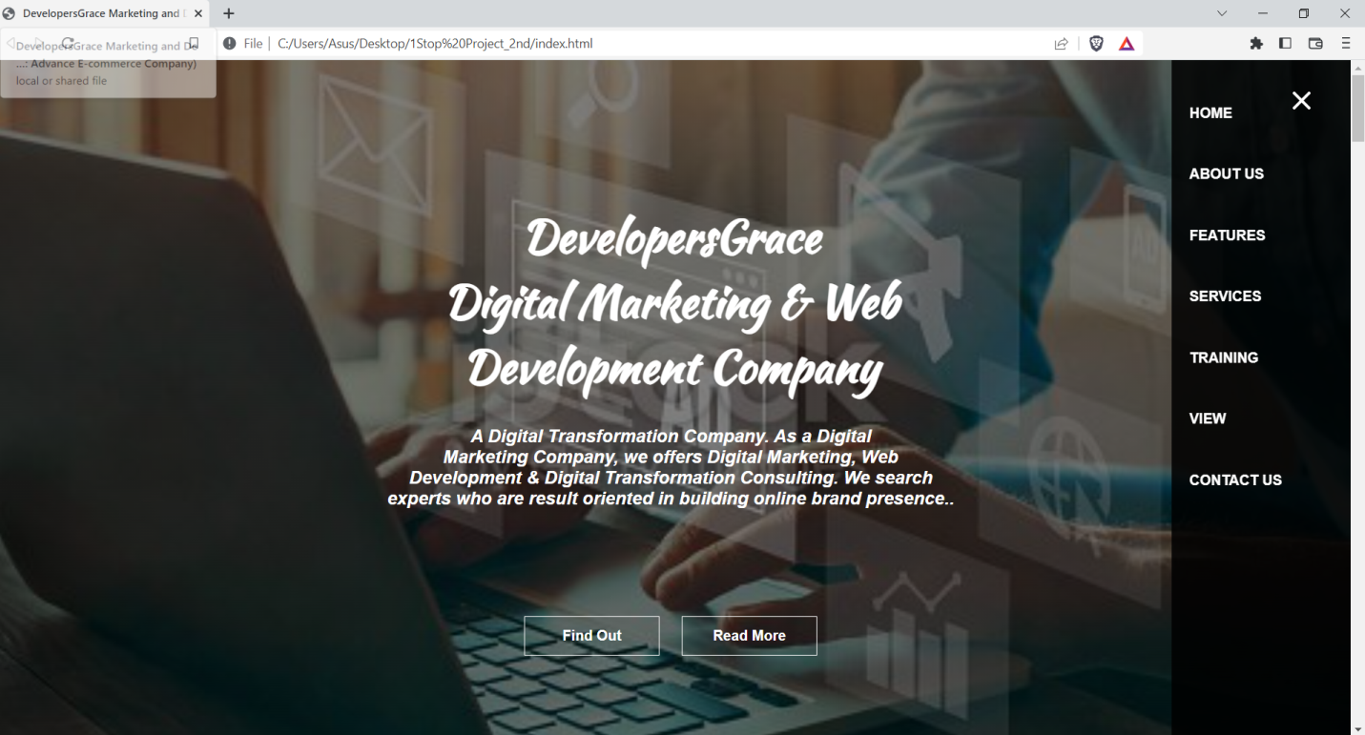

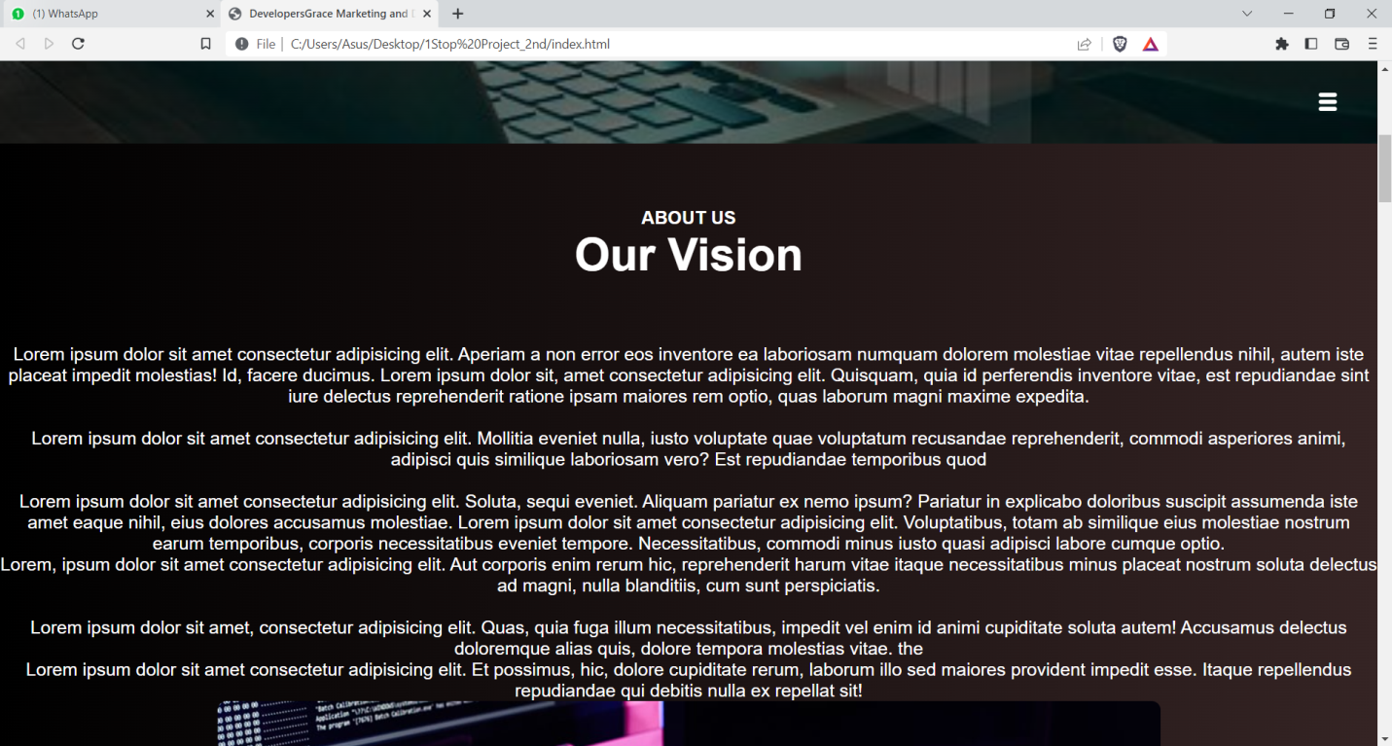

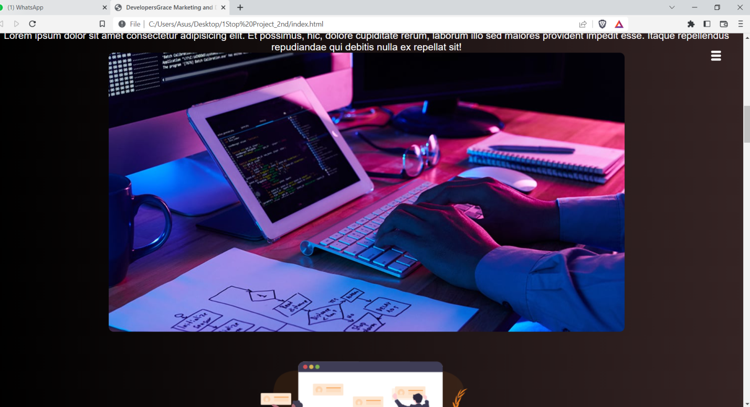

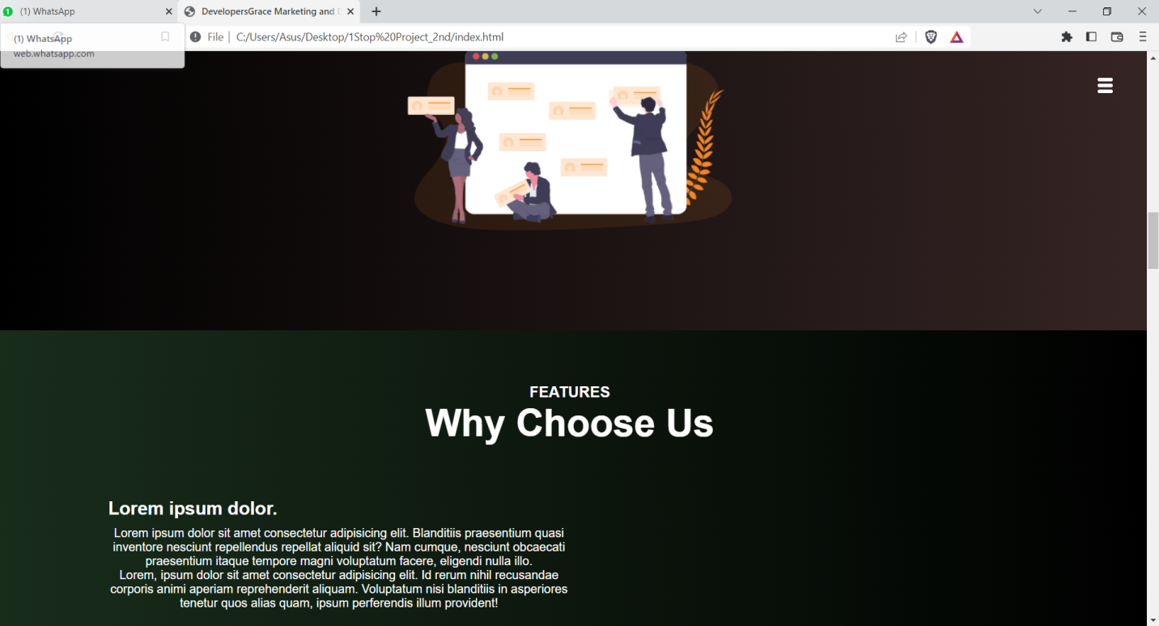

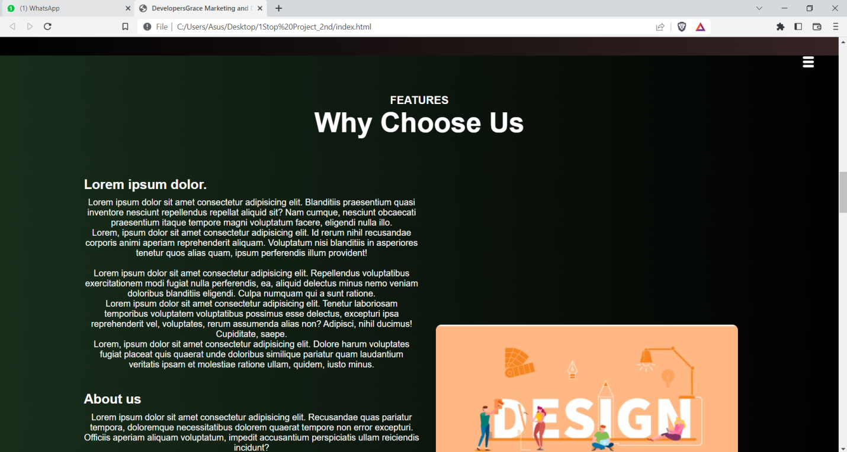

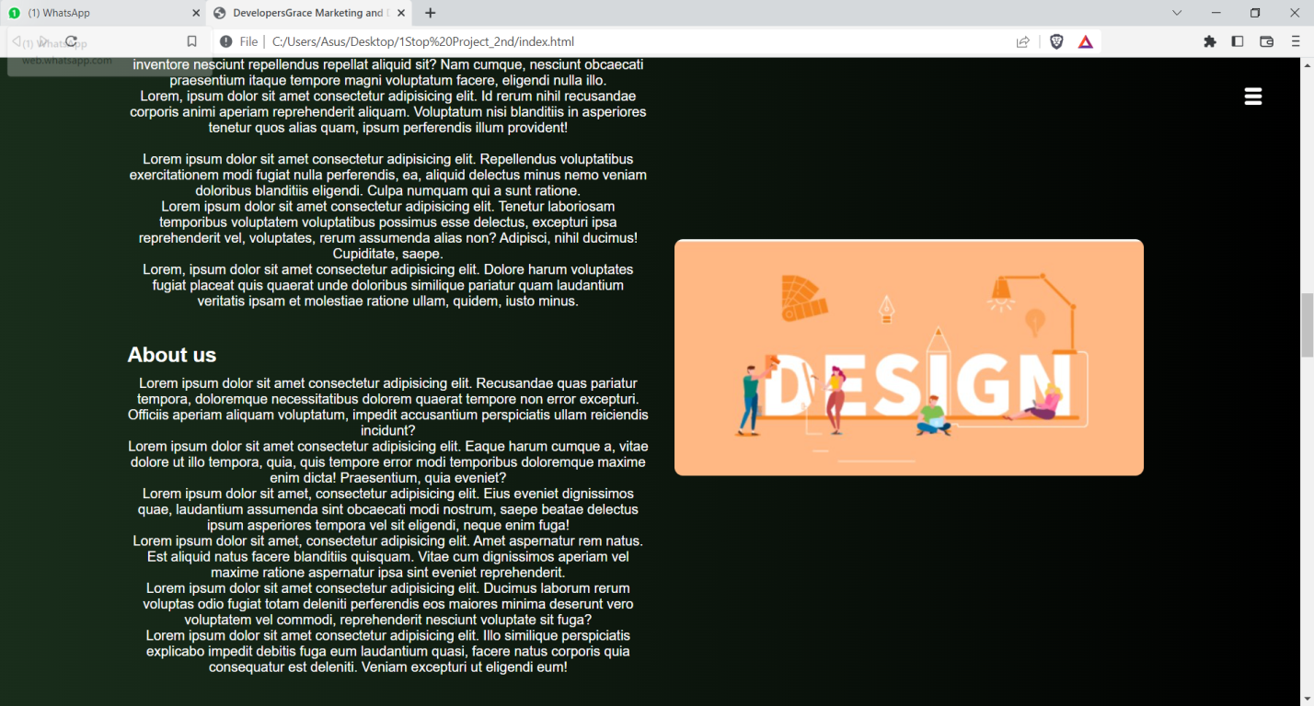

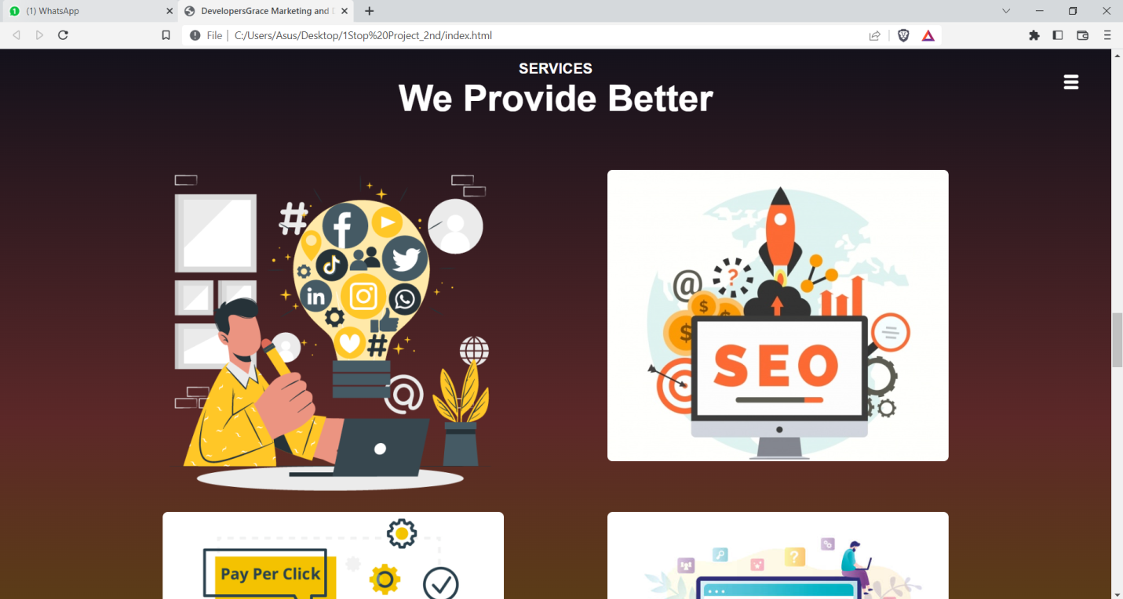

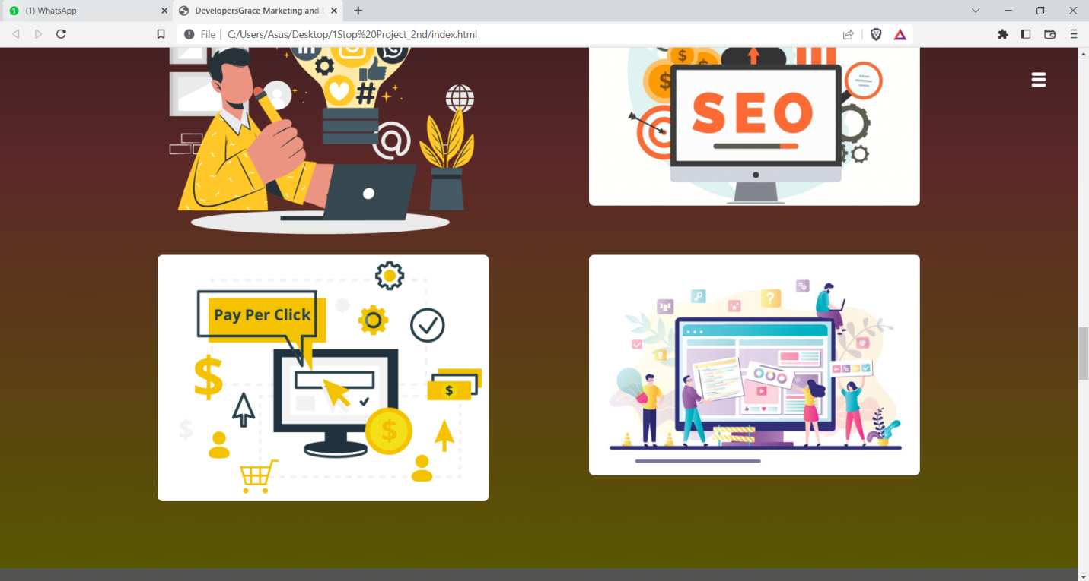

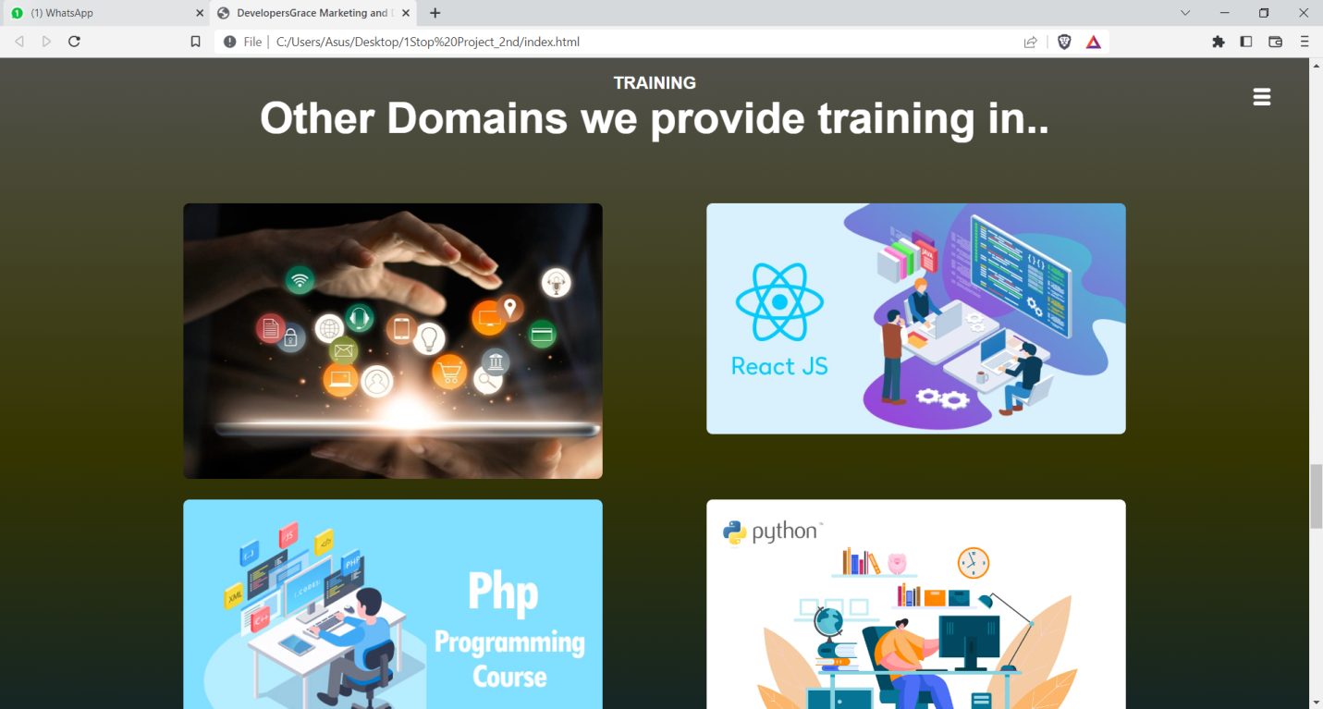

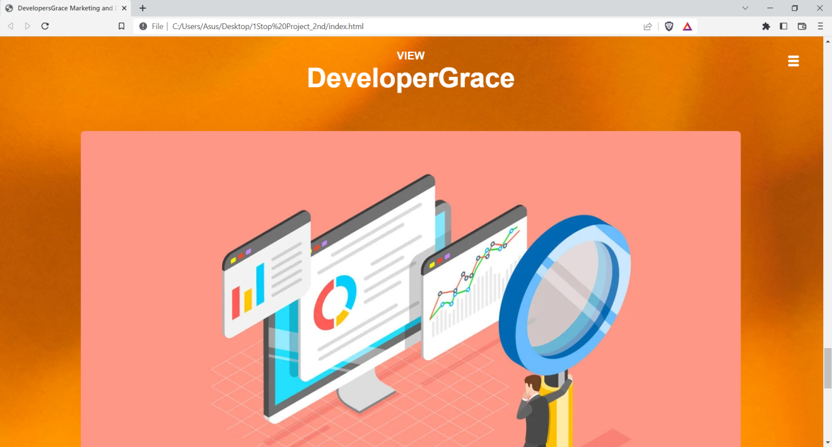

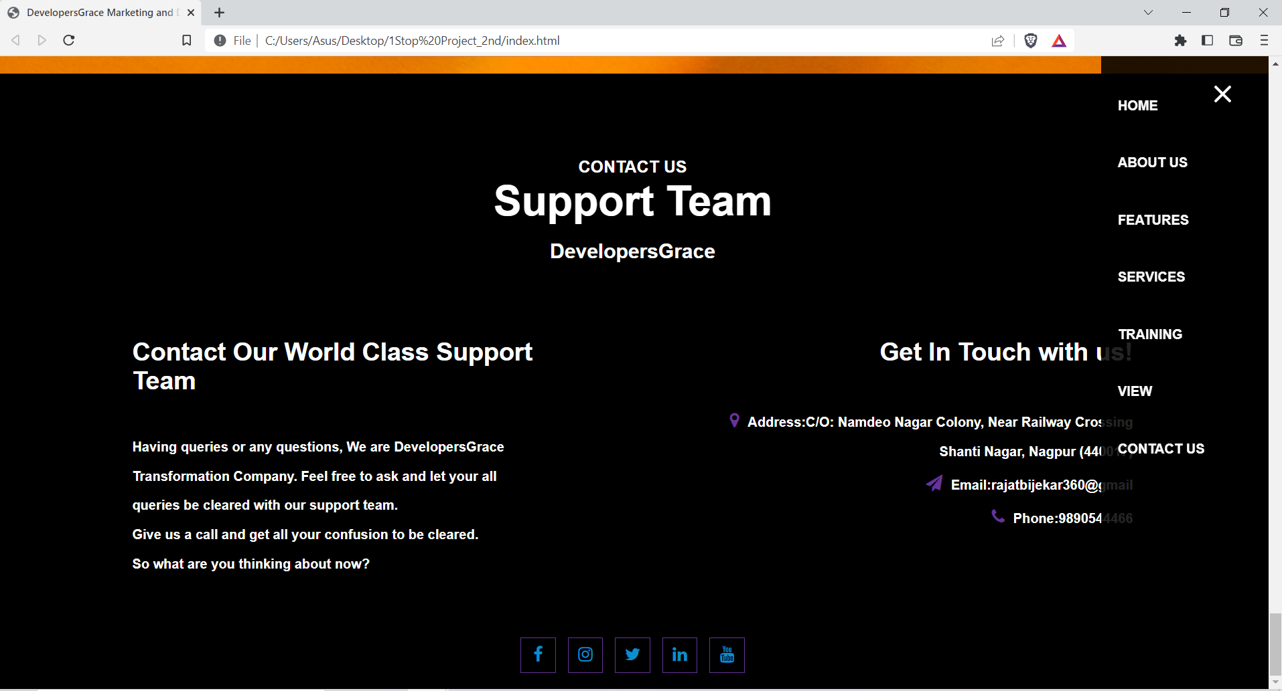

* CONCLUSION

With the help of Web development languages: HTML| CSS| Javascript, Advance E-commerce web site has been developed successfully.